Software Requirements Specification
for
Ecommerce Website for Trailmix Business
Version <X.X>

Prepared by
Group Name: <place your group name here>
Noel D. Francisco Jr. | 2019-100198 | ndfrancisco@student.apc.edu.ph

Instructor: | Manuel Sebastian S. Sanchez
Course: | BSCS-SS
Date: | 04/04/2025
Contents
Contents ii
Revisions ii
1 Introduction 1
1.1 Document Purpose 1
1.2 Product Scope 1
1.3 Intended Audience and Document Overview 1
1.4 Definitions, Acronyms and Abbreviations 1
1.5 Document Conventions 1
1.6 References and Acknowledgments 2
2 Overall Description 2
2.1 Product Overview 2
2.2 Product Functionality 3
2.3 Design and Implementation Constraints 3
2.4 Assumptions and Dependencies 3
3 Specific Requirements 4
3.1 External Interface Requirements 4
3.2 Functional Requirements 4
3.3 Use Case Model 5
4 Other Non-functional Requirements 6
4.1 Performance Requirements 6
4.2 Safety and Security Requirements 6
4.3 Software Quality Attributes 6
5 Other Requirements 7
Appendix A – Data Dictionary 8
Appendix B - Group Log 9

Revisions
Version | Primary Author(s) | Description of Version | Date Completed
Draft Type and Number | Full Name | Information about the revision. This table does not need to be filled in whenever a document is touched, only when the version is being upgraded. | 00/00/00

Introduction
<TO DO: Please provide a brief introduction to your project and a brief overview of what the reader will find in this section.>

Document Purpose
This Software Requirements Specification (SRS) document outlines the functional and non-functional requirements for an e-commerce website focused on the inventory management and online sales of trail mix items. The platform will support various packaging options, including 500g and 1kg packs of Premium Trail Mix and 1kg packs of 8-in-1 Trail Mix. The primary users of the system will include customers purchasing products, administrators managing inventory and orders, and resellers accessing wholesale options.

The scope of this SRS covers the core functionalities of the e-commerce system, including product catalog management, shopping cart, order processing, inventory tracking, customer accounts, payment integration, and reporting features. This document specifically focuses on the initial release of the system and does not yet cover future expansions such as mobile applications or third-party marketplace integrations.

Product Scope
The software specified in this document is an e-commerce platform designed to streamline the online sales and inventory management of trail mix products. It will enable customers to browse and purchase various trail mix options directly from the website. The system will feature user-friendly navigation, secure payment processing, and automated order tracking to ensure a seamless shopping experience.

The primary objective of this software is to support efficient business operations by automating key processes such as inventory control, order management, and customer interaction. Benefits of the system include increased sales reach through online availability, reduced manual errors in tracking stock levels, and improved customer satisfaction through timely order fulfillment. The platform will also provide business insights through sales and inventory reports, enabling data-driven decision-making for growth and product optimization.

Intended Audience and Document Overview
This Software Requirements Specification (SRS) document is designed for various stakeholders participating in the creation and assessment of the trail mix e-commerce platform. The primary audience includes the client, who will use this document to verify that all required features and functions are clearly defined, and the professor, who will assess the completeness, structure, and clarity of the requirements. It is also relevant to developers responsible for implementing the system, testers who will verify functionality against the documented requirements, and any future maintainers of the software.

The remainder of this SRS document is organized into sections that detail the overall system features, specific functional and non-functional requirements, external interfaces, and constraints. Readers are encouraged to begin with the overview sections (Sections 1.1 to 1.3) to understand the purpose, scope, and audience of the document. Developers and testers should then proceed to the functional requirements and system features, while the client and professor may focus on high-level features, use cases, and expected behavior of the system. Each section is designed to be self-contained for easy reference based on the reader’s role.

Definitions, Acronyms and Abbreviations
Below is a compilation of abbreviations and acronyms utilized in this Software Requirements Specification (SRS) document, arranged in alphabetical sequence:

API – Application Programming Interface

CMS – Content Management System

DB – Database

HTML – HyperText Markup Language

HTTPS – HyperText Transfer Protocol Secure

SRS – Software Requirements Specification

UI – User Interface

URL – Uniform Resource Locator

UX – User Experience

These terms are provided to ensure clear communication and consistent understanding among all readers of the document. Additional project-specific terminology may be defined in relevant sections as needed.

Document Conventions
This Software Requirements Specification (SRS) document adheres to the IEEE standard format for SRS documentation. The following conventions have been applied throughout the document to ensure consistency, clarity, and readability.

1.5.1 Formatting Conventions
Font: Arial

Font Size: 11 or 12 pt (consistent throughout the document)

Spacing: Single-spaced

Margins: 1” on all sides

Section Titles: Numbered according to IEEE standards (e.g., 1, 1.1, 1.2, etc.) and formatted in bold

Subsection Titles: Numbered and bold, matching IEEE style

Italicized text is used for comments, instructions, or placeholders not part of the final content.

1.5.2 Naming Conventions
System and Module Names: Written in Title Case (e.g., “Inventory Management Module”)

Database Entities and Variables: Written in lowercase_with_underscores (e.g., product_id, customer_name)

File Names and URLs: Written in lowercase with hyphens (e.g., order-summary.html, www.example.com/trailmix-store)

These conventions are intended to support clear communication among all stakeholders and ensure uniform documentation practices across the project.

References and Acknowledgments
<List any other documents or Web addresses to which this SRS refers. These may include user interface style guides, contracts, standards, system requirements specifications, use case documents, or a vision and scope document. >

Overall Description

Product Overview
The trail mix e-commerce platform described in this SRS is a new, self-contained product designed to manage the online sales, inventory tracking, and order processing of healthy trail mix products. It is not a follow-up to an existing software system, nor is it a module within a larger suite. The platform will function as a complete solution for both retail customers and resellers, allowing product browsing, secure checkout, order history tracking, and administrative inventory control.

The system will be composed of several key components: the User Interface (UI) for customers and admins, the Application Server where business logic is processed, and a Database Server where all product, customer, and order information is stored. External systems interfaced with the platform will include payment gateways and optionally, email or SMS services for notifications and order confirmations. The system will be accessed through standard web browsers.

Product Functionality
The key functions of the NuttyLoves e-commerce platform include:

Create Account: Enables new users to register by providing their personal and login information. This function ensures secure access and customer profile creation in the database.
Login/Logout: Authenticates registered users and grants them access to personalized features such as shopping and order history. Users can also securely log out of their sessions.
Manage Account: Allows users to update profile information (e.g., name, password, address) and view their account activity. Ensures user data remains current and secure.
Create Order: Customers can add products to their cart and proceed to checkout. The system validates stock, calculates totals, and creates an order record in the database upon successful confirmation.
Manage Orders: Admins can view, track, and update orders placed by customers. This includes changing the order status (e.g., Pending, Shipped, Delivered) and ensuring timely fulfillment and customer notifications.
Manage Products: Administrators can add, update, or delete product listings. This includes editing product name, description, price, and stock quantity.
Manage Inventory: Admins can monitor and update product stock levels. This ensures product availability is accurate and prevents overselling.
View Sales Report: The system compiles and displays daily order counts and revenue totals. Admins can visualize sales performance and export reports for recordkeeping or analysis.

Design and Implementation Constraints
The NuttyLoves e-commerce platform will be developed with a focus on functionality, performance, and user accessibility. Effective deployment and configuration management will be implemented to ensure reliable operation across customer and admin interfaces.

The system must adhere to established software design principles, including the use of Unified Modeling Language (UML) for architectural modeling and a modular development approach for scalability and maintainability. It will interface with a MySQL database to manage product data, inventory, orders, and sales records within the existing server infrastructure.

Security is a key consideration, particularly in handling customer information, order transactions, and admin access. Additionally, the platform must be scalable to support increasing product listings, growing customer traffic, and future integration with additional services such as payment gateways or delivery tracking.

Assumptions and Dependencies
These assumptions, if incorrect or changed, may affect the design, implementation, and overall performance of the NuttyLoves e-commerce system.

- The system assumes that Admin users will input and maintain accurate data for products, inventory levels, and order statuses, as these are critical to smooth platform operations.

- The platform depends on a stable connection with its MySQL database for reliable storage and retrieval of product, order, and sales data.

- The system assumes that the web hosting environment and server infrastructure will support the expected traffic and provide reliable uptime during development, deployment, and operation.

- It is assumed that Customers and Admins will have access to compatible devices (computers, tablets, or smartphones) with modern web browsers to use the system effectively.

- Testers and admins are expected to be familiar with the platform’s features and have basic technical knowledge to ensure proper system testing and usage.

Specific Requirements

External Interface Requirements

User Interfaces
The ecommerce website will feature a simple, web-based user interface designed for the Administrator and customers. Key components of the interface include:
• Customers can browse available products, add items to their cart, place orders, and receive real-time order notifications through a responsive and intuitive front-end. They will also be able to securely view their order history.
• Administrators have access to a secure dashboard where they can manage products, update inventory, process customer orders, and monitor sales. The interface allows for quick edits to product listings, real-time stock adjustments, and order status updates. It also provides sales reports to help track performance and support business decisions.

Hardware Interfaces
The NuttyLoves e-commerce platform will interact with the following hardware components:

Computers, Tablets, and Smartphones: Used by both Customers and Admins to access the platform. Customers use these devices to browse products, place orders, and track purchases, while Admins manage products, inventory, orders, and sales reports.

Servers: Essential for hosting the website, handling data transactions, and ensuring reliable performance of all platform functions, including product display, order processing, and report generation.

Software Interfaces
The NuttyLoves e-commerce platform will integrate with the following software components:

Web Browsers: The platform will be accessible via modern web browsers, enabling both Customers and Admins to interact with the system seamlessly across devices.

Database Management System (MySQL): All product data, inventory levels, order records, and sales information will be stored and managed through a relational database system to ensure data integrity and accessibility.

Functional Requirements
3.2.1. Create Account
The system shall allow users to register by entering required details such as name, email, and password. Upon submission, the system validates the input and stores the information securely in the customer database.

3.2.2. Manage Account
The system shall enable customers to view and update their account information. This includes editing name, email, and password, while maintaining security and data integrity.

3.2.3. Create Order
The system shall allow logged-in customers to add products to their cart, proceed to checkout, and confirm their order. It must validate inventory availability, calculate totals, and save order details to the database upon confirmation.

3.2.4. Manage Orders
The system shall allow administrators to view a list of all customer orders, including order date, total amount, and current status. Admins can update an order’s status (e.g., Pending, Shipped, Delivered) and the system shall notify customers of changes.

3.2.5. Manage Products
The system shall allow administrators to create, edit, or delete products. Product data includes name, description, price, and stock quantity. Changes must be reflected immediately in the product catalog.

3.2.6. Manage Inventory
The system shall allow administrators to view and adjust product stock levels directly. Adjustments must be saved in real time to avoid overselling or stock mismatches.

3.2.7. View Sales Report
The system shall generate a sales report that summarizes orders by date, total revenue, and order count. The admin can view this information on-screen and export it as a downloadable image (JPG) of the report layout and graph.

Use Case Model
Use Case Diagram
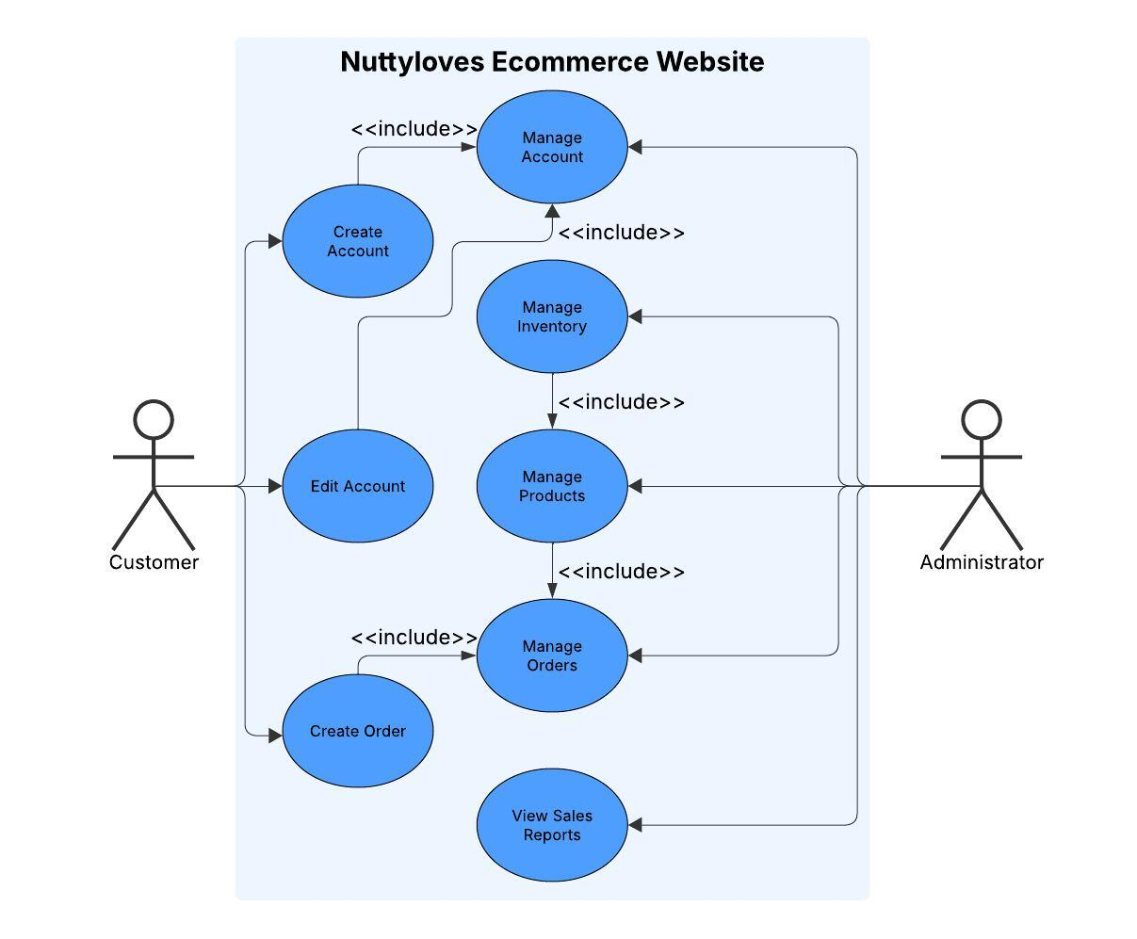
.

Use Case #1 (Manage Account)
Use Case Name: | Manage Account
Scenario: | Registered users want to update their profile or account settings.
Triggering Event: | User logs in and navigates to the account settings page.
Brief Description: | A customer accesses their account settings to edit or update personal details such as password, email, or shipping address. The system updates and confirms the changes.
Actors: | Customer
Related Use Cases: | Create Account
Stakeholders: | NuttyLoves Customers: to ensure accurate delivery and contact information.
Preconditions: | Customer must be logged in.
Postconditions: | User profile is updated.
Flow of Activities: | Actor | System
Flow of Activities: | 1. Customer logs into account.  2. Opens account settings.  3. Updates information. | 2.1 Displays editable account fields.  3.1 Validates and saves changes.
Exception Conditions: | 3. Invalid data entry or system save error.

Use Case #2 (Manage Inventory)
Use Case Name: | Manage Inventory
Scenario: | Admins want to update stock levels.
Triggering Event: | Admin opens inventory management.
Brief Description: | Admin can view stock quantities and make changes. The system updates the database and ensures the store reflects current inventory.
Actors: | Admin
Related Use Cases: | Manage Products
Stakeholders: | NuttyLoves Warehouse Team: ensures product availability.
Preconditions: | Admin is authenticated.  Products must be listed in the system.
Postconditions: | Stock levels are updated.
Flow of Activities: | Actor | System
Flow of Activities: | 1. Admin opens inventory panel.  2. Updates quantities. | 1.1 Displays list of products and stock.  2.1 Validates and saves stock updates.
Exception Conditions: | 2. Entry exceeds allowed range.  2. Database save failure.  2. Invalid data entry.

Use Case #3 (Manage Products)
Use Case Name: | Manage Products
Scenario: | Admins want to update the product catalog
Triggering Event: | Admin accesses the dashboard.
Brief Description: | Admin creates, edits, or removes products from the catalog. The system updates the database and reflects changes in the store front.
Actors: | Admin
Related Use Cases: | Manage Inventory,Manage Orders
Stakeholders: | NuttyLoves Admins: to manage the product offering.
Preconditions: | Admin is authenticated.
Postconditions: | Product catalog is updated.
Flow of Activities: | Actor | System
Flow of Activities: | 1. Admin logs in.  2. Opens product manager.  3. Edits/adds/deletes product. | 2.1 Displays product list.  3.1 Validates and saves changes.
Exception Conditions: | 1. Validation error or database failure.  1. Duplicate entry.  3. Invalid data.

Use Case #4 (Manage Orders and Create Orders)
Use Case Name: | Manage Orders and Create Orders
Scenario: | Customers place orders while admins oversee and update their statuses.
Triggering Event: | A customer clicks "Checkout" after adding products to the cart or an admin logs in and accesses the orders dashboard.
Brief Description: | Customers complete a purchase by providing necessary shipping and payment information. The system verifies the data, creates an order, updates inventory, and sends confirmation. Admins can later view, track, and update the order's status (e.g., from Pending to Shipped or Delivered). Notifications are sent accordingly.
Actors: | Admin and Customer
Related Use Cases: | Manage Products
Stakeholders: | NuttyLoves Admin Team: to deliver and support customer service.  NuttyLoves Customers: Expect accurate and timely delivery.
Preconditions: | The customer is logged in.  Products are available in inventory.  Admin is authenticated.
Postconditions: | A new order is stored in the system.  Inventory is updated.  Order status can be tracked and modified.  Customers receive order notifications.
Flow of Activities: | Actor | System
Flow of Activities: | 1. Customer proceeds to checkout.  2. Customer enters shipping and payment info.  3. Customer submits order.  4. Admin logs in and opens order list.  5. Admin selects an order.  6. Admin updates order status. | 1.1 Displays cart summary and order form.  2.1 Validates stock and payment data.  3.1 Creates order, updates inventory, sends confirmation.  4.1 Displays all orders with details.  5.1 Shows full order information.  6.1 Saves status update and notifies customer.
Exception Conditions: | 2. Customer provides invalid data or payment fails.  3. Item is out of stock during checkout.  5. Admin attempts to update a non-existent order.  6. System fails to send notification.

Use Case #5 (View Sales Report)
Use Case Name: | View Sales Report
Scenario: | Admins want to analyze and review sales data.
Triggering Event: | Admin accesses the sales report section in the dashboard.
Brief Description: | The Admin generates a report to analyze recent sales, total revenue, and product performance. The system fetches data and presents the report in a readable format.
Actors: | Admin
Related Use Cases:
Stakeholders: | NuttyLoves Admin Team: to evaluate business performance.
Preconditions: | Sales data is recorded in the system.
Postconditions: | Sales report is generated and displayed.
Flow of Activities: | Actor | System
Flow of Activities: | 1. Admin logs in.  2. Navigates to sales report.  3. Views report. | 2.1 Retrieves and processes sales data.  3.1 Displays report (e.g., graphs, tables).
Exception Conditions: | 2. Data not found or system processing error.

Use Case #6 (Create Account)
Use Case Name: | Create Account
Scenario: | New users want to register and use the NuttyLoves platform.
Triggering Event: | User clicks on the "Sign Up" or "Register" button.
Brief Description: | When a new customer wants to place an order, the system allows them to create a new user account by filling out a registration form. The system validates the data, saves the new account, and notifies the customer of successful registration.
Actors: | Customer
Related Use Cases: | Manage Account
Stakeholders: | NuttyLoves Admin Team: ensures secure storage of user credentials.
Preconditions: | User has not registered previously.
Postconditions: | A new user account is created and saved.
Flow of Activities: | Actor | System
Flow of Activities: | 1. Customer clicks “Sign Up”.  2. Customer completes form.  3. Submits registration. | 2.1 Validates data and checks for duplicates.  3.1 Creates user record and confirms registration.
Exception Conditions: | 2. Missing or invalid input.  3. Email already exists in the system.

Other Non-functional Requirements

Performance Requirements
The NuttyLoves e-commerce platform must be fast, reliable, and scalable to support smooth operations for both customers and administrators. Key user interactions such as account creation, login, and profile management should be processed within 2 seconds, ensuring quick access and a seamless user experience. Placing orders—including inventory validation and payment confirmation—must be completed within 5 seconds, even during peak usage. Admin actions like updating product listings or adjusting inventory should reflect on the storefront within 3 seconds to maintain real-time accuracy. The system must be capable of handling concurrent access by at least 100 customers and 10 admins without performance degradation. Additionally, the platform should be available 99.5% of the time, excluding scheduled maintenance, and must perform consistently across all modern browsers and devices, including desktops, tablets, and smartphones. Generating sales reports should take no more than 5 seconds for up to 1,000 orders, supporting efficient decision-making. All transactions and data access must be secured using HTTPS, with strict access control based on user roles to protect sensitive customer and business information.

Safety and Security Requirements
The NuttyLoves e-commerce platform must implement essential safeguards to protect against data loss, unauthorized access, and misuse. All data transmissions must use HTTPS to ensure secure communication, especially on mobile devices. Role-based access control must restrict administrative functions to authorized users only. The system must enforce secure logins with strong passwords and automatic session timeouts to reduce risks during inactivity. Regular backups must protect customer, order, and inventory data, while user actions affecting sensitive data should be logged for auditing. Personal information must remain private and accessible only to authenticated users, ensuring platform security and customer trust.

Software Quality Attributes
The NuttyLoves e-commerce platform must prioritize usability, maintainability, and reliability. The user interface should be intuitive and responsive across devices, requiring minimal training for customers and admins. The system must be modular and well-documented, allowing developers to make updates or add features with minimal disruption. It should perform reliably under normal and peak loads, with automated error handling and data persistence to prevent loss during interruptions. Regular backups and clear system logs will further support stability and issue resolution.

Other Requirements

Appendix A – Data Dictionary/ERD
ERD (Entity Relationship Diagram)

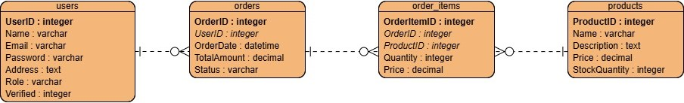
Data Dictionary
Entity | Attribute | Data Type | Description | Constraints
users | UserID | integer | Unique identifier for each user | Primary Key, Unique
 | Name | varchar | Name of the user | Not Null
 | Email | varchar | Email of the user | Not Null
 | Password | varchar | Password of the user | Not Null
 | Address | text | Address of the user | Not Null
 | Role | varchar | Role of the user | Must be one of predefined roles
 | Verified | int | Verification of the user | Not Null
order_items | OrderItemID | integer | Unique identifier for each order item | Primary Key, Unique
 | OrderID | integer | References the order associated with the order item | Foreign Key (orders)
 | ProductID | integer | References the product associated with the order item | Foreign Key (products)
 | Quantity | integer | Quantity of the order item | Not Null
 | Price | decimal | Price of the order item | Not Null
orders | OrderID | integer | Unique identifier for each order | Primary Key, Unique
 | CustomerID | integer | References the customer associated with the order | Foreign Key (customers)
 | OrderDate | datetime | Order Date of the order | Not Null
 | TotalAmount | decimal | Total Amount of the order | Not Null
 | Status | varchar | Status of the order | Not Null
products | ProductID | integer | Unique identifier for each product | Primary Key, Unique
 | Name | varchar | Name of the product | Not Null
 | Description | text | Description of the product | Not Null
 | Price | decimal | Price of the product | Not Null
 | StockQuantity | integer | Stock Quantity of the product | Not Null

Appendix B - Group Log

Appendix C – Test Plan/Test Cases

